1. **Hero Banner and Important Notice （CBOL and MBOL）**

* Regional demo （for reference only）

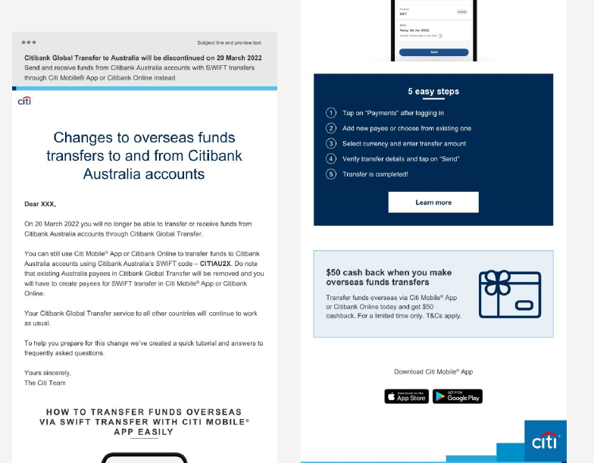

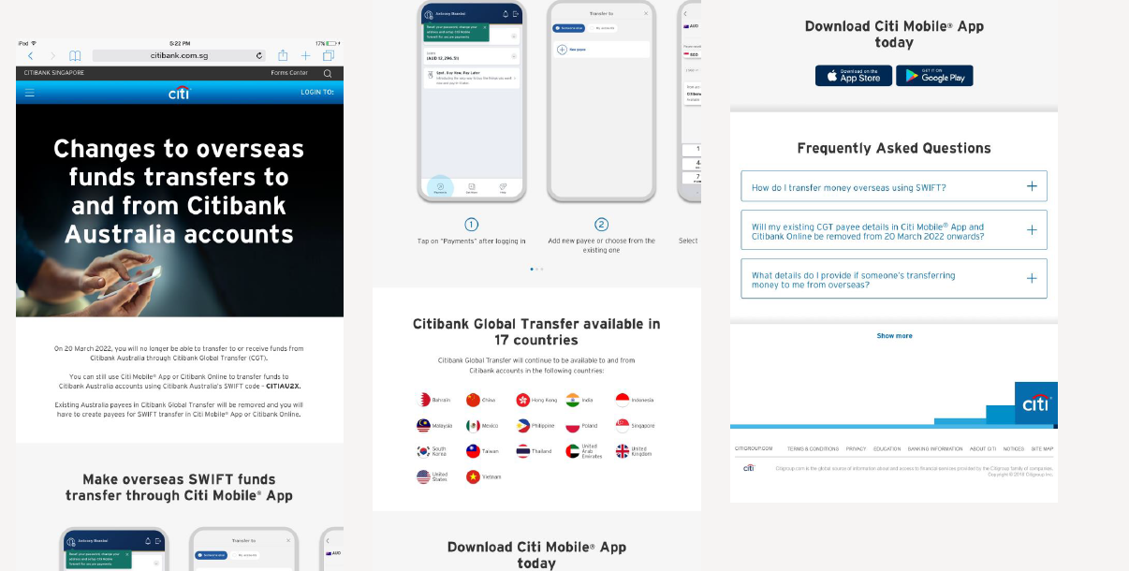

Wording on Banner:

* EN script

**Changes to overseas funds transfers to and from Citibank Australia account**

**关于花旗银行全球速汇通服务变更的通知**

Wording of customer notice:

Dear Customer,

On 24 April 2022 you will no longer be able to transfer or receive funds from Citibank Australia accounts through Citibank Global Transfer.

You can still use Citibank Online to transfer funds to Citibank Australia accounts using Citibank Australia’s SWIFT code -CITIAU2X. Do note that existing Australia payees in Citibank Global Transfer will be removed and you will have to create payees for SWIFT transfer in Citibank Online.

Your Citibank Global Transfer service to all other countries will continue to work as usual.

To help you prepare for this change we’ve created a quick tutorial and answers to frequently asked questions.

Yours sincerely,

The Citi Team

尊敬的客户，

自 2022 年 4月24日起，您将无法通过花旗全球速汇通服务向澳大利亚花旗银行账户进行转账或接受来自澳大利亚花旗银行账户的汇款。

您的收款人名单中澳大利亚花旗银行的全球速汇通收款人信息将被自动移除。

您可登录花旗中国网上银行([www.citibank.com.cn](http://www.citibank.com.cn))创建新的海外收款人（澳大利亚花旗银行的 SWIFT 代码为：CITIAU2X)，并通过网上银行“转账汇款”功能进行跨境汇款。

花旗银行全球速汇通服务的其他国家/地区仍照常运作。

为了更好的帮助您为这一变化做好准备，我们准备了SWIFT渠道跨境汇款功能教程供您参考。

花旗银行中国

How to transfer funds overseas via SWFIT transfer with Citibank Online easily

5 easy steps

<GIF animation insert> -

5 easy steps

1. Click on “Payment & Transfer after logging in
2. Add new payee (Overseas Payee-Other Overseas Foreign Currency Account) or choose from existing
3. Enter transfer amount and other required information
4. Verify transfer details and submit
5. Transfer is submitted!

快捷教程：

如何使用花旗网上银行通过SWIFT转账轻松完成跨境汇款

简单五步

1) 登录花旗网上银行后点击“转账汇款”

2) 添加新收款人(海外收款人:外币账户-其他海外收款人外币账户)或从现有收款人中选择

3) 输入转账金额和其他所需信息

4) 验证转账详情并提交

5) 转账申请已提交！

**Citibank Global Transfer Available in 17 Markets**

Besides China, Citibank Global Transfer will remain available to and from Citibank accounts in the following markets:

* Bahrain
* Hong Kong
* India
* Indonesia
* Malaysia
* Mexico
* Philippines
* Poland
* Singapore
* South Korea
* Taiwan
* Thailand
* United Arab Emirates
* United Kingdom
* United States
* Vietnam

**花旗银行全球速汇通服务目前仍可在 17 个国家/地区使用**

包括中国在内，花旗银行全球速汇通服务仍可用于以下国家/地区的花旗银行账户：

•巴林

•中国香港

•印度

•印度尼西亚

•马来西亚

•墨西哥

•菲律宾

•波兰

•新加坡

• 韩国

•中国台湾

•泰国

•阿拉伯联合酋长国

•英国

•美国

•越南

Frequently Asked Questions

常见问题

**How do I transfer money overseas using SWIFT?**

Pre 24 April 2022, you will need to set up a payee through the ‘Another Overseas Bank Account’ route (highlighted below) on Citibank Online. This will require you to enter in the payee’s details, including address and bank account details. Bank account details can include a SWIFT code, International Bank Account Number (IBAN) or another country specific code. If you are unsure, please check with the payee who will be able to confirm with their bank what routing code to use. Please also note currently the daily limit for SWIFT transfer through Citi Online is USD 20,000 or equivalent foreign currencies.

**如何使用 SWIFT 进行跨境汇款？**

2022 年 4月24日之前，您需要在花旗网上银行通过“其他海外收款人外币账户”（如下所示）设置收款人，详细信息包括地址和银行账户详细信息。其中，银行账户详细信息包括 银行名称、收款国家、地区、SWIFT 代码。如果您不确定以上信息，请联系收款人核实确认。请注意，使用 SWIFT转账每日交易限额为 20,000 美元或等值外币。

**Will my existing CGT payee details in Citi Mobile® App and Citibank Online be removed from 24 April 2022 onwards?**

Existing Australian CGT payee details will be removed in Citi Mobile® App and Citibank Online from 24 April 2022 onwards. Before then, please be reminded to use the account details you previously used to create CGT payees to create your payees for SWIFT transfer in Citibank Online, together with the corresponding SWIFT code below:

**我在花旗网上银行中的现有全球速汇通收款人会在2022年4月24日之后被移除吗？**

从 2022 年 4月24日起，

您的收款人名单中澳大利亚花旗银行的全球速汇通收款人信息将被自动移除。

在此之前，请使用您之前用于创建速汇通收款人的账户详细信息及以下SWIFT代码将澳大利亚花旗银行的账户创建为您的 SWIFT 转账收款人。

|  |  |  |  |
| --- | --- | --- | --- |
| **Country/Region国家/地区** | **Bank Name银行名称** | **Corresponding SWIFT Code SWIFT 代码** | **BSB code**  **BSB代码** |
| AUSTRALIA | CITIGROUP PTY LIMITED | CITIAU2X | NA |

**What details do I provide if someone’s transferring money to me from Australia CITIGROUP PTY LIMITED?**

To receive an international funds transfer, customers will need to provide their account number and Citibank China’s SWIFT code (**CITICNSX**) to the payer.

**如果有人从澳大利亚花旗银行账户向中国花旗银行的账户转账，我应该提供哪些详细信息？**

接收跨境汇款，您需要向付款人提供您在中国花旗银行的账号和中国花旗银行的 SWIFT 代码 (CITICNSX)。

**Will the SWIFT transaction take longer if made on a weekend, a public/bank holiday, or after the cut-off time?**

SWIFT transactions usually take up to 72 hours to process. There may be circumstances where this could take longer, such as if public holidays and weekends occur side by side.

**如果在周末、假日或交易截止时间后进行SWIFT 转账是否需要更长时间？**

SWIFT 转账通常需要 72 小时完成。在某些情况下可能需要更长时间，例如遇到公共假期和周末。

**Are there any fees or charges from Citi to implement this change?**

A fee waiver will be offered to customer who transfer fund to Australia CITIGROUP PTY LIMITED.

**本次跨境汇款方式变化后，我通过中国花旗银行账户向澳大利亚花旗银行账户汇款是否收取额外费用？**

为了尽可能的减少对您的影响，我们目前会将为您减免对澳大利亚花旗银行账户SWIFT转账产生的费用。

Should you have any enquiry, please contact Citibank China service hotline: 95038.

如您有任何问题，可咨询花旗银行客服热线：95038.